OSINT INVESTIGATION REPORT
Subject: OpenAI
Analyst: Muppala Pooja
Team: Intelligence Accuracy / OSINT Track — Day 1 Practical
Date: July 3, 2026
Classification: Public Sources Only (OSINT)
HQ: 1455 3rd Street, San Francisco, CA 94158
Intelligence Cycle Application
- Collection: Public sources (OpenAI.com, Wikipedia, CNBC, PitchBook, Tracxn).
- Processing: Categorized into founding, structure, funding, products, leadership, legal, competitors.
- Analysis: Identified recurring themes — capital dependence, leadership instability, transparency risks.
- Assessment: Evaluated implications for IPO readiness, investor confidence, and reputational exposure.
1. Executive Insight
OpenAI is a mission-driven AI company that evolved from nonprofit roots into a public benefit corporation. Despite record fundraising ($852B valuation), it remains unprofitable due to compute costs. Its rapid growth (ChatGPT, API, Codex, DALL·E, Sora) is tempered by leadership churn and legal controversies, creating a dual narrative: commercial dominance vs. governance fragility.
2. Founding & Evolution
- Founders: Altman, Brockman, Sutskever, Musk, Schulman, Karpathy, others.
- Initial Funding: $1B pledged by tech leaders and firms (Musk, Hoffman, Thiel, Infosys, AWS).
- Mission: Ensure AGI benefits humanity.
- Trajectory: From open research tools (Gym, Universe) → consumer adoption (ChatGPT) → enterprise scale.
3. Corporate Structure
- 2015: Nonprofit.
- 2019: Capped-profit subsidiary.
- 2025: Public Benefit Corporation (PBC).
- Control: OpenAI Foundation retains oversight.
4. Financial Position
- 2025: $40B raised at $300B valuation.
- 2026: $122B raised, $852B valuation — largest private round in history.
- Revenue: ~$25B annualized, ~$2B monthly.
- Microsoft: $13B+ investment plus Azure infrastructure.
- Risk: Heavy compute costs → reliance on investor capital.
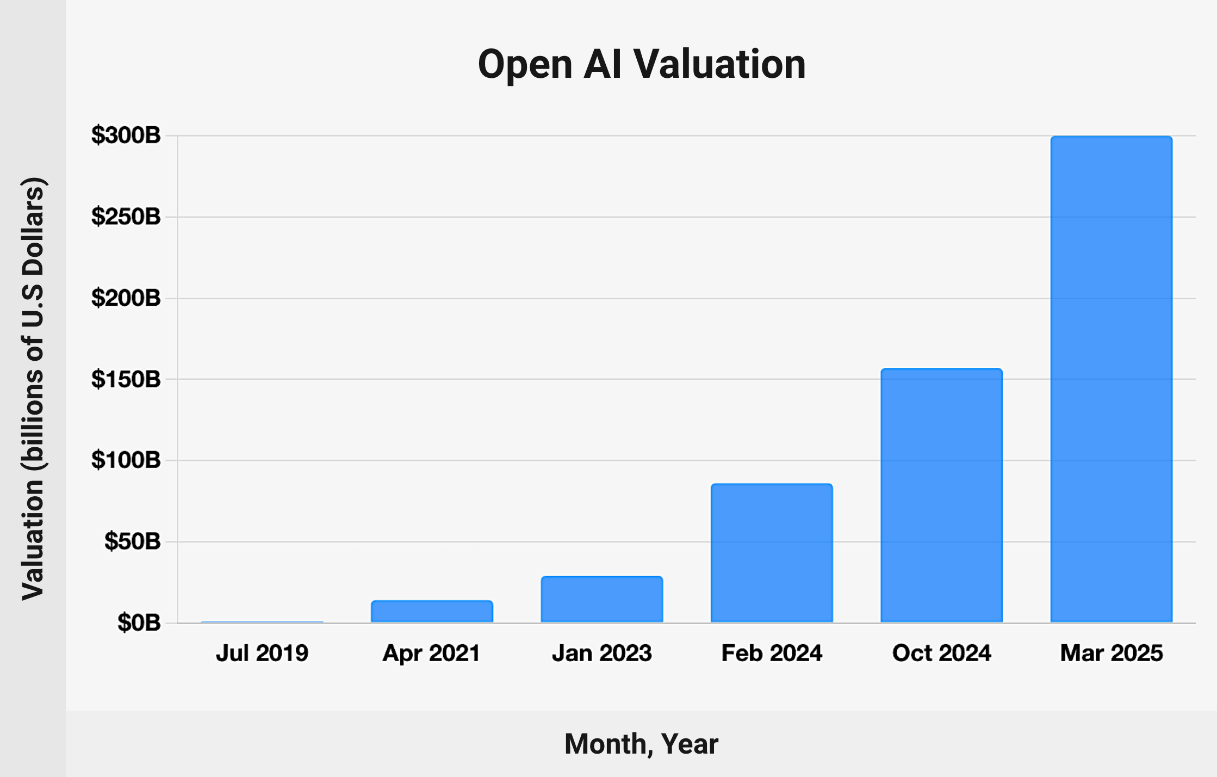
5. Market Scale
- ChatGPT: 1B+ monthly users, 50M+ paid subscribers.
- Enterprise: 9M+ business users (~40% of revenue).
- API: 15B tokens/minute.
- Codex: 2M weekly users.
- DALL·E & Sora: Expanding multimodal AI.
6. Leadership Dynamics
- 2023: Altman briefly removed, reinstated after revolt.
- 2024: Departures of safety leaders (Sutskever, Leike).
- 2026: Fidji Simo’s medical leave → reshuffle (Lightcap, Dresser, Brockman).
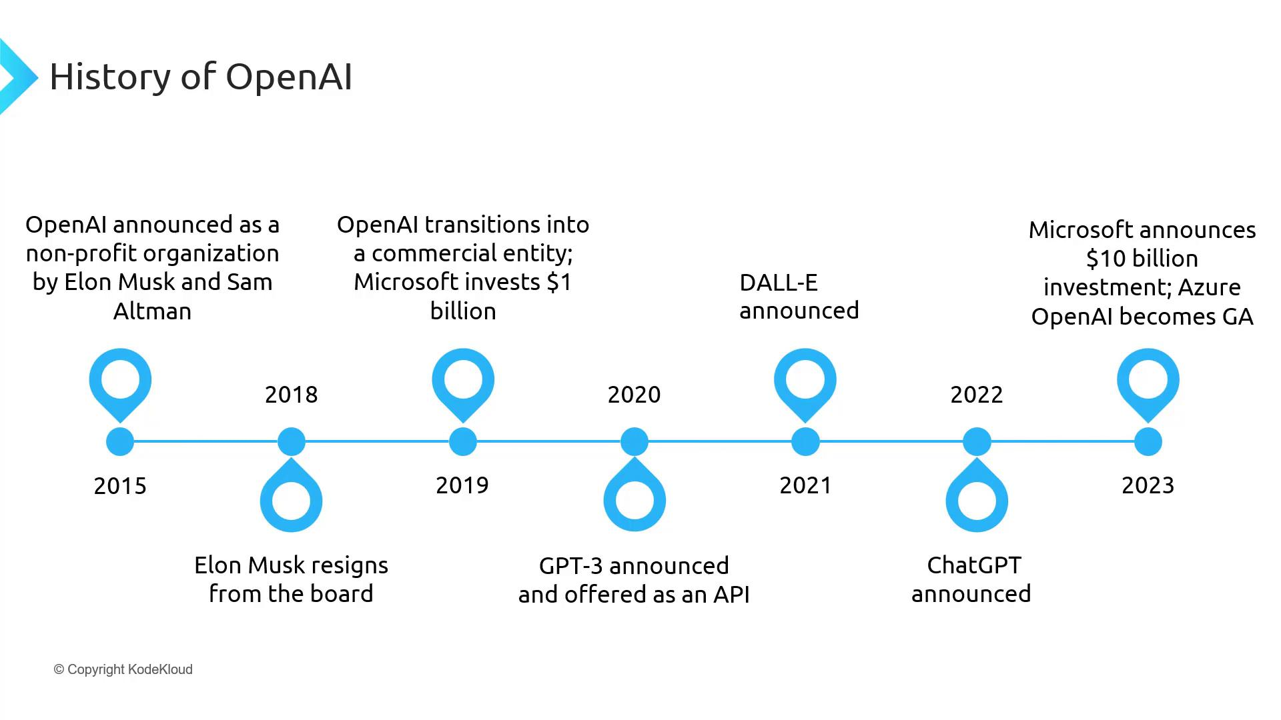
📅 Leadership Timeline Visual:
- 2023: Altman crisis
- 2024: Safety exits
- 2026: Reshuffle
7. Legal & Ethical Boundaries
- 2023–24: Copyright lawsuits (NYT, authors).
- 2024: Non-disparagement controversy → revoked.
- 2026: Florida AG lawsuit, wrongful death suits, Musk’s case dismissed.
Pattern: Transparency & accountability repeatedly challenged.
8. Competitive Landscape
- Anthropic: Claude, safety-focused.
- Mistral AI: European open-weights.
- DeepSeek: Chinese open-weights.
- Cohere: Enterprise RAG & sovereign AI.
OpenAI leads in scale, rivals emphasize safety & sovereignty.
9. Intelligence Assessment
- Capital Position: Strong fundraising, weak profitability.
- Leadership Stability: Repeated crises → organizational strain.
- Governance Design: Foundation-controlled PBC balances mission vs. investor demands.
- Public Trust Exposure: Transparency controversies → reputational risk.
10. Source List
- openai.com
- en.wikipedia.org/wiki/OpenAI
- CNBC, TechCrunch
- Tracxn, PitchBook
- LegalClarity, NYT

Conclusion
OpenAI represents both extraordinary growth and persistent fragility. The company’s capital strength — record fundraising and unmatched valuation — is offset by structural vulnerabilities, including heavy reliance on investor capital and escalating compute costs. Its leadership dynamics reveal recurring instability, with high-profile departures and reshuffles that raise questions about organizational resilience. Meanwhile, transparency controversies — from non-disparagement agreements to undisclosed coalition funding — underscore reputational risks that could affect regulatory scrutiny and public trust.
From an intelligence perspective, OpenAI’s trajectory illustrates the tension between scale and sustainability. The hybrid governance model (Foundation-controlled PBC) is designed to balance mission with investor demands, but its effectiveness will be tested as the company approaches IPO. Competitively, OpenAI leads in adoption and product breadth, yet rivals emphasize safety, sovereignty, and efficiency, carving out differentiated positions in the generative AI landscape.
Assessment: OpenAI’s future hinges on whether it can convert investor-driven expansion into durable profitability while maintaining credibility in governance and ethics

